**Worked Confirmed Window**

# Geoff Anderson G3NPA and Aki Yoshida JA1NLX

## 1.0 GENERAL

The Worked/Confirmed window is designed to show a summary of the Band/Mode combinations worked for a specific prefix. Additionally, it will show specific summary information for the callsign entered in the Logbook Entry window, if that callsign has been entered into the log previously. Some elements of the way this information is displayed are configurable by the user.

An empty window is shown here:

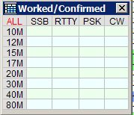

WCW_1

The bands and modes displayed are derived from your BandPlan and whether you have the Stats column marked with a "Y". The more bands and modes you have so marked, the larger will be the table shown above.

To drag/drop Worked/Confirmed Window columns, Right click on the Worked/Confirmed Window. Click on menu option. See details in the paragraph 4.0.

The table becomes active as soon as a recognized prefix is entered into the "Call" edit box of the Logbook Entry window. The table will remain blank if the particular country has not been logged before, but if the prefix has been recorded previously, then the appropriate Band/Mode combinations will be activated, as shown in the example below.

**Note**: The Worked/Confirmed window title bar will change and include that of the prefix entered, the Operator and the type of QSLs to be included for confirmations (see below)

**Note**: The current Band/Mode cell is indicated by the boarder with clear line. (See 40M CW below)

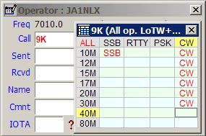

WCW_2

**Note:** User can add "SAT" column. Any QSO that is logged with a SAT_NAME and PROP_MODE of SAT will show in this column and not in the CW/SSB/whatever column.

## 2.0  WORKED/CONFIRMED WINDOW MENU

A right mouse click with the cursor anywhere on the Worked/Confirmed window will produce the following set of menu options:

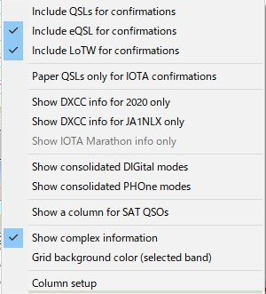

new WCW_3

### 2.1 Include QSL/eQSL/LotW for Confirmations

This menu item allows the user to select what QSO confirmed information is displayed. This will also affect the colors displayed in the DX Spots window.

An example showing the changes that can be observed when selecting different "Include for confirmation" options.